Claxton Parish Council
Claxton Biodiversity Plan

Document Control
Adopted date | June 2026 | Minute reference | 26.52.01
Last reviewed | June 2026 | Minute reference | 26.52.01
Next review date | May 2027

November 2024

Introduction – The challenges
1. The recent publication of the ‘State of Nature 2023’ the most comprehensive report on the state of the UK’s biodiversity, makes for depressing reading due to the significant loss of flora and fauna species over the last 50 years. As a result of the extensive scientific studies and understanding of its biodiversity, the UK is described as one of the most nature depleted countries on Earth. This is despite the ongoing efforts made by conservation Non-Governmental Organisations (NGOs), visionary private landowners and their supporters – nature and the environment continue to be degraded across the UK.
2. Whilst the South Yare Valley continues to be an important location for many species of both over wintering migratory wildfowl and summer migrants, over the last 30 years, we have experienced significant loss of farmland bird species due to the intensification of arable farming. This process has also adversely impacted on farmland flora and fauna through the reduction or loss of ‘farmland weed’ species together with the invertebrates and pollinators they sustain with adverse consequences for the whole ecosystem.
3. Whilst we recognise the importance of an efficient and productive agricultural sector, as consumers and taxpayers we are all stakeholders in the process of growing food. As such we have a legitimate and important voice through our democratic systems and the active lobbying of conservation NGOs, to influence on how this sector should be managed. The challenge is to develop a system which recognises the importance and relevance of the environment, the economics of food production and successfully balances the competing and potentially contradictory requirements of both.

A Bio-diversity action plan to help implement HM Government policy.
4. Whilst in a post Brexit world, these challenges continue to exercise HM Government policy makers, the Environmental Improvement Plan published on the 31 January 2023, sets out the actions we must take to help us restore nature, tackle environmental pollution, and increase the prosperity of our country. Under the 2021 Environment Act, public authorities (including town and parish councils) who operate in England must consider what they can do to conserve and enhance biodiversity in England.
5. There is a clear line of sight from the high-level strategic policy of HM Government to the policy and decision making undertaken at local level by parish councils such as Claxton. The aim is to sustain, conserve and enhance biodiversity across their parishes. Clearly to deliver the policy objectives parish councils will need to work with local nature conservation organisations, landowners, local experts and parishioners to develop and implement a biodiversity action plan. This plan should cover the possible actions the council will take itself, as well as support and interventions from local bodies and individuals. Only through a collective approach and partnership working with like-minded, motivated individuals and organisations will improvements to biodiversity be delivered across the country.
6. A useful starting point for this process is to undertake a biodiversity audit of council holdings and/or the whole council area drawing upon existing information and sites which are relevant to the plan and its strategic aims. This process will help to map what exists across the parish and to identify priorities for managing, sustaining and improving the biodiversity of the parish. The process will need to be actively managed with local expertise providing the necessary assistance and operational support to develop and deliver the bio-diversity action plan.

A starting point in Claxton
7. This process has commenced in Claxton following a ‘parish walk’ on the 18th December 2023 with Reg Land, a professional ecologist and resident of Surlingham who is retained by the Claxton Pit’s Trust to advise on the management of Ducan’s Marsh - an ~ 8 acre Site of Special Scientific Interest (SSSI) within the parish. This walk was informed with an initial briefing document included for information as annex 1. The initial report of this event prepared by Reg Land, together with a narrative and mapping information of the Claxton landscape using Google Maps, describing the main habitats is attached as annex 2 to this discussion document.
8. The report contains useful information regarding both existing hedgerows and woodland in the parish and importantly includes various recommendations for enhancing wildlife (flora and fauna) in Claxton. These recommendations should not be read in isolation, but for those protected sites such as Ducan’s Marsh and St. Andrew’s Churchyard will cross reference with existing management plans and Norfolk Wildlife Trust (NWT) surveys. There are also links with the ongoing work of the South Yare Wildlife Group (SYWG) to promote the ‘Wild Patch’ initiative as well as their continuing work with installing nest boxes for swifts.
9. From initial considerations of this survey of the Claxton landscape, it is apparent that despite the extent of arable agriculture across the parish, which at 591 hectares is 72% of the parish land, there remains significant areas such as the protected sites, woodland, certain hedgerows, heritage trees, grazing marshes and gardens which are all important for biodiversity. Our challenge is to identify what is doable and where can the parish council and parishioners have the maximum impact to sustain and improve biodiversity for the foreseeable future. The audit approach continues with current work being to complete an audit of the ’significant’ trees in the parish which are visible and accessible to the public. Currently, there are 3 ancient/veteran oak trees recorded on the Woodland’s Trust ‘Ancient Tree Inventory’ for the parish with more to add as the audit progresses.
10. Work has also been completed to monitor and record information regarding bat species using Ducan’s Marsh both as a roosting site and for feeding, as well as mapping the various flocks of house sparrows feeding and nesting across the parish. These small flocks tend to be quite confined in their range and are easily overlooked but nevertheless provide an indicator of the ‘biodiversity’ and presence of formerly common bird species. The same is also true of the small flocks of starlings which still nest in the village as well as the migrant house martins and swifts which still nest in the village.

What is our vision?
11. Given the legal obligations placed on the parish council to produce a bio-diversity action plan, it will assist those involved in this process to consider their vision as to what we, as a parish, wish to achieve in the next 5 years. This can be defined by the delivery of agreed objectives and a commitment to monitor their delivery, as part of a local and national strategy to sustain and improve biodiversity. The action plan provided at annex c provides some broad aims and objectives to enable this process to be managed and monitored by the parish council and includes information on the current progress on what has been delivered against these objectives.

Annex 1 - Claxton Parish – Biodiversity Plan 2024
16 December 2023

Briefing for parish walk to identify some notable sites/features relevant to the biodiversity plan.

1, Claxton and Carleton St. Peter Village Hall grounds
The village hall grounds and boundaries provide opportunities for some active management to contribute to the biodiversity of the village. Whilst much of the site is used for car parking or as an amenity for village events, there is an area to the rear of the hall that could be used as a wildflower meadow, a hedgerow has been planted on the northern boundary and there are a number of mature trees planted along the eastern boundary which may be suitable for bat or bird nest boxes. There is also an established oak tree on the south west boundary which I have been advised was planted in 1981 to commemorate the construction of the new village hall.

2. Peasecod Loke
Peasecod Loke is a bridle way which runs south for ~ 0.75 mile from the Street, Claxton to the Slade and continues as a footpath to Ashby St. Mary. The area on the Street prior to the northern end of the Loke contains two notable/veteran oak trees growing in the boundary hedgerows.
At approximately 50 metres on the western edge of the northern end of the Loke is the Claxton Oak – an ancient oak tree, with a trunk circumference > 8 metres and estimated at between 400 – 600 years old. As far as I am aware this tree has no ‘tree protection order’ TPO but is listed on the Woodland’s Trust Ancient Tree Inventory ACI).
A little further into the Loke is a second veteran pollarded oak tree on the eastern boundary which has a circumference of > 6 metres. I assume no TPO and not currently listed on the ACI.
It has subsequently been confirmed using the South Norfolk website information that there are no TPOs in place to protect specified trees in Claxton.
The Loke has hedgerows along much of its length which has largely been replanted in the last 10 years by the landowners. The landowner to the east cuts the hedges adjacent to his arable land to provide a ‘tidy hedge’ whereas the landowner to the west actively manages his hedgerows in a more sympathetic manner for the benefits of wildlife and birds.
The Loke can be considered as a Holloway due to its sunken topography in its mid-section where there is a further veteran oak on its eastern boundary. Its sandy banks in this area contain rabbit burrows. The Loke is well used by birds and is a frequent hunting location for sparrowhawks and tawny owls.
There is a wide ‘slumped hedge’ with a wide base, which runs from the Loke eastwards towards The Home Pease separating a meadow from an arable field on its southern side. This hedge sits adjacent to a ditch and is well used by feeding birds including Reed Buntings and occasional Woodcock in the winter.
The Loke bisects the Slade another bridleway/byway which passes from Folly Lane in the east to the Home Pease/St. Andrew’s Church, Claxton in the west.
The significant trees will be monitored as part of the ongoing tree audit.

3. The Slade
The Slade is a boundary pathway (Slade means open space between banks/valleys) and links the three local churches (Carleton St. Peter, Ashby St. Mary and St. Andrew’s, Claxton). Hedgerows were planted ~ 10 years ago by The Claxton Manor Estate – John Heathcote, and they are managed for the benefits of birds and insects. My recent observations have confirmed that migratory blackbirds, redwings and fieldfares feed on the various fruits and berries in this hedge as well as mixed flocks of tits and finches. I have not seen any yellowhammers this year on the Slade. The adjacent arable land is high value and intensively cultivated. However, this land is used by hares, rabbits, migratory birds including lapwings, fieldfares, redwings and resident buzzards, kestrels and marsh harriers.

4. St. Andrew’s Churchyard
The churchyard is actively managed as part of the Churchyard Conservation Scheme/ Churchyard Challenge and has been surveyed by Norfolk Wildlife Trust (NWT) who have provided a report and conservation plan. There are 8 nest boxes in the churchyard which I have installed and maintain. I have purchased from the SYWG an owl box to be installed in the veteran oak tree located in the south-east corner of the churchyard.
St. Andrew’s church was awarded the Ecochurch Bronze Award by A Rocha UK on the 23 December 2021 which confirms the active management of the site for the benefit of flora and fauna.
There is a reasonably comprehensive report prepared by NWT following their survey in 2021/22. Claxton Parish Council make an annual financial contribution towards the upkeep of the churchyard.
The boundary hedge is ‘patchy’ and contains scrub elms which as they mature become vulnerable to attack from Dutch elm beetle. However, the site does contain a good variety of native trees including crab apples, a mature wild service tree (Sorbus torminalis) and various native trees.
The ancient oak in the south east corner of the churchyard estimated at 400 years old is listed on the Woodland’s Trust ATI.

5. The Home Pease
This byway connects The Street opposite Manor Farm with the properties adjacent to the St. Andrew’s church – Staithes Barn Cottages. This track is ~ 1000 metres and bisects meadows formerly used for grazing cattle. Approximately 10 years ago the hedges on the northern section were replanted by the estate with a variety of native species. These hedges have been managed to ensure berries and fruits are available for the overwintering birds. The hedgerows also attract significant numbers of insects, particularly in late summer and early autumn. The hedgerow is also regularly used by feeding bullfinches (2xpairs) and mixed flocks of tits and finches.
Towards the centre of the track is the Sumps Plantation and irrigation reservoir which has an island. The reservoir allegedly has a concrete base and is spring fed such that it has never dried out. Water levels are controlled by a simple sluice which drains into a ditch that runs to the north down into the drainage dykes on Claxton marsh.
The reservoir has a fixed pump house and is used as a source of water for irrigation using fixed pipework to flexible hoses and a water monitor. I have seen a young otter swimming and calling in the reservoir as well as the occasional kingfisher. There is a regular raft of ~ 20 ducks including mallard and gadwall, as well as moorhen (the wildfowl are fed by the estate). The site is well used by spring migrants including chiff chaff and blackcap.
There are also several veteran oak trees adjacent to the reservoir as well as a poplar plantation and field maple. One of the veteran oaks was regularly used as a nesting site for barn owls until the oak split and lost a significant part of its structure to reveal the nesting space. This oak is listed on the Woodland’s Trust ACI. This is also a good area for insects and birds due to the ivy flowers and berries.

6. The Street
There are several veteran oak trees bordering the Street as well as a water course at Claxton Corner and various drainage ditches forming marginal wetlands. Whilst this is not unusual for the South Yare Valley, the ditches do run behind the ‘domestic dwellings’ on the south side of the Street. This helps to increase the diversity of flora and fauna adjacent to the domestic dwellings where they are largely left undisturbed and able to enter the adjacent gardens. Relatively unusual birds have been seen in this area of Claxton including Cetti’s warbler, little egret, great white egret, cuckoo and woodcock as well as rarities such as the white stork.
The Street also has at least two resident flocks of house sparrows, nesting house martins and swifts nesting under the pantiles of the roofs of several houses. However, in the last 30 years we have lost the yellow hammers, tree sparrows and turtle doves that formerly were present in and around Folly Lane and The Street, along with large flocks of linnets. This is likely to have arisen due to the intensification of arable crop production including the sowing of winter cereals.

7. The Church Marsh – former Glebe Land
At the eastern end of the Street on its southern side is an area of wetland and marsh formerly church glebe land which is owned by the Diocese of Norwich. This is an area of ~2.5 acres of alder and willow carr, reedbed and wetland which is not actively managed (apart from some grass cutting and ditch dredging). It borders the area which was formerly all known as Ducan’s Marsh which runs along the western boundary of Carleton Beck to Ashby St. May and Thurton. This area includes Ducan’s Marsh SSSI. The Church Marsh is subject to the Norwich Diocese policy for former glebe land which is currently under revision and due to be issued in December 2024.

8. Ducan’s Marsh
Ducan’s Mash is an 8-acre SSSI owned by the Claxton Pit’s Trust and actively managed to a 5-year plan prepared by Reg Land a professional ecologist. Full documentation including a management plan, records etc are available for DM as a protected site and a discrete area of biodiversity within the parish of Claxton. It is was under consideration by Natural England for a Citizen Zoo project for the reintroduction of the large marsh grasshopper. But due to the relative isolation of the site from other habitats suitable for the LMG the site was not approved for the project.

9. The Claxton Orchard
This is an area of approximately 1000 sq. metres behind no 3 The Warren on its northern boundary which is the site of the former village allotments. It has been planted with various fruit trees by the Pit’s Trust on behalf of the Parish Council and is managed by trustees. Due to operational difficulties in managing the site, Claxton Parish Council has now returned this orchard to the Claxton Manor Estate.

10. Mill Lane and Claxton Marsh
This area includes a track and hedgerow which has a small flock of house sparrows as well as some notable and veteran oaks in the area where it joins the marsh. The pathway runs parallel with Carleton Beck to the river Yare and includes reed boundaries which extend for ~ 1000 metres to the river. This area is used by otter and water vole as well as overwintering wildfowl and migratory birds such as stonechats and short eared owl during the winter and reed warbler and sedge warbler, hobby in the summer as well as resident Cetti warbler. This area is also used by various raptors including barn owl, buzzard, harrier and occasional hen harrier and short eared owl. The area is also used by grasshopper warbler, reed buntings and bearded tits.

Paul Carter
23 May 2026

Priorities
What can we do to sustain and improve the biodiversity of the parish? What should be the priorities? Should we set ourselves SMART objectives to help with the management and delivery of the planned improvements?

Some thoughts- birds:
In the last 30 years, Claxton has lost the bulk of its specialist farmland birds due to the intensification of arable farming and the sowing of winter cereals removing fields being left fallow over winter. This situation is aggravated by the ongoing desire to ‘tidy’ field margins and hedgerows thereby removing plant life which could provide sources of nectar, pollen and fruits for insects, birds and small mammals.
The consequences of such changes in arable farming have caused the decline/loss of local populations of yellowhammers. tree sparrows, turtle doves, grey partridge, skylarks with significant reductions in the numbers of linnets, chaffinches and greenfinches.
The populations of goldfinches appear to have increased due to the impact of garden flora and garden sited bird feeders. Similarly, the local populations of great, blue, long-tailed tits and coal tits appear reasonably healthy due to the availability of nest boxes and garden feeders. Reed buntings also visit gardens in the Street during the winter months to feed on seed from garden bird feeders.

House sparrows – there are several small populations of house sparrows in Claxton which are very localised and as such can be vulnerable to environmental changes which impact on their feeding and breeding behaviours. These birds will use nest boxes but prefer nesting sites in houses and outbuildings.

House martins – (~10/15 pairs) continue to nest on various houses throughout Claxton building nests and making use of artificial nests erected by homeowners on their properties.

Swifts – there is a small population (~5/6 pairs) that continue to use nesting sites under the pan tiles of various properties along the Street and the Warren.

Flora and invertebrates
Encourage the community to introduce plants and shrubs (native and introduced cultivated species) both in public and private spaces which provide sources of pollen and nectar for insects throughout the year. Provide areas and habitats to support and encourage invertebrates.

Annex 2 - CLAXTON PARISH BIODIVERSITY APPRAISAL 2023
This brief report presents some basic information on the wildlife habitats of Claxton that may be of use in the preparation of a biodiversity appraisal as part of the parish council’s duty under the Environment Act 2021. The information is presented as a series of maps along with a brief description of the habitats and some suggestions on how to enhance the parish for biodiversity. The habitats were mapped using Google Earth and with the help of local knowledge. The habitats were originally mapped using the UK Habitat Classification but the results have been simplified here to make them more understandable to the lay reader. It should be noted that this report does not set out to present a detailed description of the wildlife species found in the parish.

The parish can be divided into a number of distinctive zones with their associated habitats. Each of these habitats have their own characteristic wildlife.
The floodplain of the River Yare is almost entirely made up of grazing marshes with wet ditches and areas of wet woodland, largely associated with Claxton Manor estate. An additional notable habitat is the Carleton Beck and its embankment running through the grazing marsh comprising rough grassland. The valleys of the Carleton and Hellington Becks, marking the eastern and western boundaries of the parish, respectively, have areas of wet woodland and marshy grassland. These low-lying areas supports Water Voles, the rare Norfolk Hawker dragonfly and are a favoured area for Marsh Harriers to hunt. Alongside the Carleton Beck is the outstandingly wildlife-rich Ducan’s Marsh with its rare wildflowers and invertebrates.

Away from the floodplain the parish is dominated by arable farmland with a network of hedgerows and roadside verges and some small areas of woodland. Some arable fields have been converted to woodland in recent years, notably adjacent the Hellington Beck. Arable farmland has value for wildlife but, sadly, many of the once familiar species such as Yellowhammer, Linnet and Skylark have declined as a result of the intensification of agriculture. However, where hedgerows and the grassy verges alongside them are managed sympathetically they are an important wildlife habitat.

The bulk of the parish’s habitation lies between the floodplain and the arable land. The habitats here include the buildings and gardens and areas of grass paddocks and rough grassland. There are a number of large Oak trees in this area, including the Claxton Oak. Many common species of bird are associated with the gardens, often attracted by bird feeding, and even the buildings can be important for breeding birds like House Sparrow and Swift.

Although the map only shows the habitats in Claxton parish it should be noted that these continue into adjacent parishes and in some cases create an important wildlife corridor through the arable farmland. Most notably these include the wetland habitats in the valleys of the Carleton and Hellington Becks.

The map below shows the main habitats in the parish and the table summarises the area they occupy. Hedgerows have been mapped separately for clarity.

The table shows the percentages of the different habitats in the parish. This clearly shows the dominance of arable farmland, covering over 70% of the parish. Buildings and gardens make up only 3% of the parish. The remainder comprises a mix of woodland, grassland and wetland. The bulk of this comprises the large area of grazing marsh in the floodplain. The value of these areas for wildlife depends greatly on how they are managed. For example, the area of so-called species-poor grassland, in the form of grassy paddocks, is quite high but supports very few species, possibly due to frequent mowing or the application of fertilizer, which eliminates many species of wildflower. The area of grassland that is species-rich, that is, of high value for wildlife, is very small and largely restricted to the grounds of St Andrew’s church. No matter how ‘good’ or ‘bad’ an area is for wildlife, however, it can be enhanced to attract more species if managed more sympathetically.
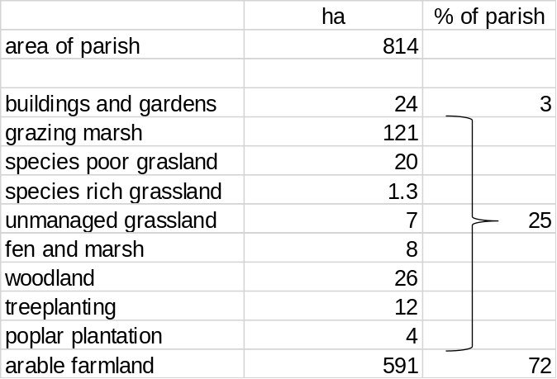
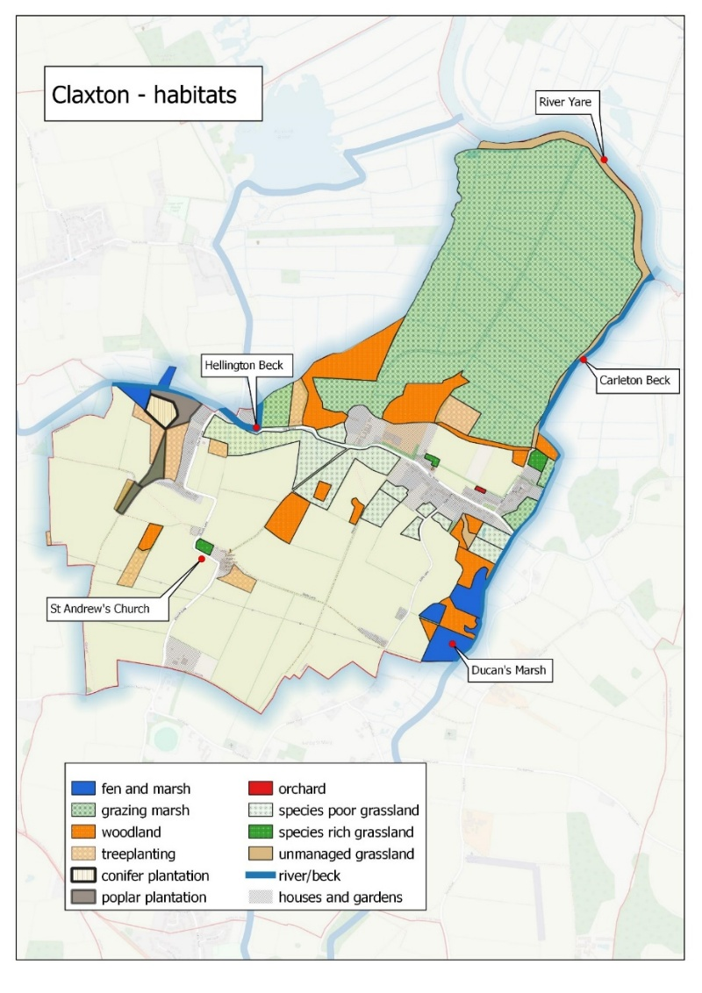
Protected land in Claxton
The following map shows the land that has been designated as part of the Broads National Park. In addition, Ducan’s Marsh has been designated as a Site of Special Scientific Interest and a Special Area of Conservation in recognition of its national and international importance, respectively, for wildlife. An area of marsh adjacent to Ducan’s Marsh has been designated as a County Wildlife Site, which is a voluntary designation entered into by the landowner.
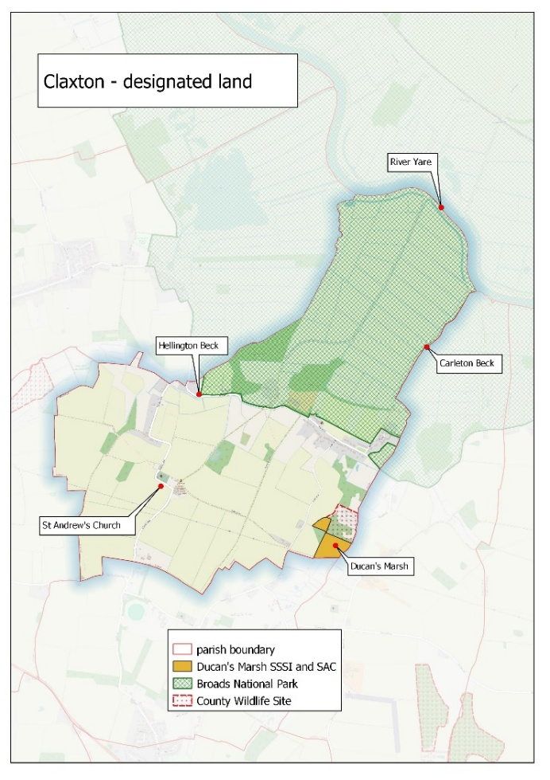

Environmental change in Claxton
The following is a brief description of two landscape changes that have occurred in the parish.
Hedgerows
The intensification of agriculture following the Second World War resulted in the widespread loss of hedgerows and hedgerow trees as fields were enlarged to accommodate modern machinery. Nationally, we have lost 50% of our hedgerows since then and around 60% of the hedgerows we still have are poorly managed for wildlife. In some areas this loss has had a dramatic impact on the landscape and wildlife.

The length of hedgerow present in Claxton, c1880 (as shown on the OS First Edition map) was about 26km. The present-day length is about 20km with the loss largely restricted to two distinct areas as shown on the map. This loss of overall length has been partly compensated by additional hedge planting in recent years and, notably, the sympathetic hedgerow management of the Claxton Manor estate. In summary, the loss of hedgerows in Claxton has not been as great as the national average and the arable landscape of the parish has changed relatively little in over 100 years.

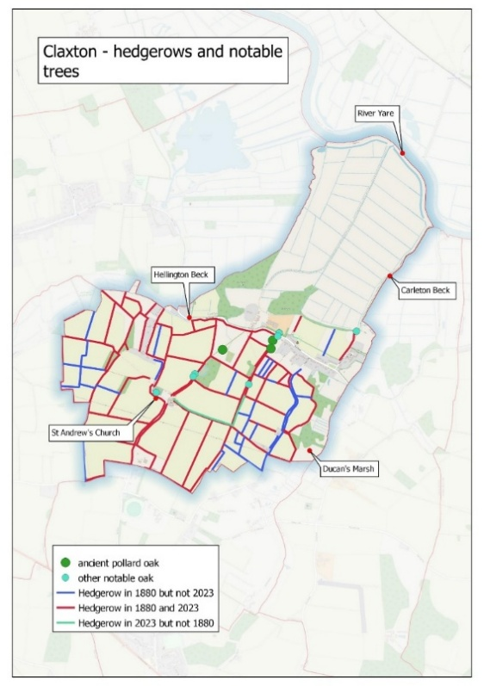

Woodland
A comparison of the woodland cover in c1880 and today shows that none has been lost. Two large areas of woodland around Claxton Manor and another at Sump’s Plantation, totalling 15 hectares (37 acres), are shown on the 1880 map. Since then, the area of woodland has expanded to over 40 hectares (98 acres). This has been achieved through planting on 12 hectares (29 acres) of arable land in recent years and the natural colonisation of marshes along the Hellington and Carleton Becks with Alder trees. Whilst an increase in woodland is generally welcomed in some cases this has resulted in the loss of wildlife associated with marshy grassland.

Some suggestions for enhancing wildlife in Claxton
The following are possible actions that could be adopted by the parish council and parishioners.
- Protecting and maintaining the wildlife interest of Ducan’s Marsh SSSI by the Pits Trust will be important.
- St Andrew’s churchyard probably has some of the last areas of grassland that is rich in wildflowers and the present sympathetic management should continue.
- The Church land (the Church Marsh former glebe land) forms part of the wildlife corridor along the Carleton Beck. This patch of wetland should be retained in its present state.
- Hedgerow and tree planting – areas where hedgerows can be planted using native species should be identified. The possibility of planting along Folly Lane could be explored (whilst recognising concerns about road safety).
- Heritage trees – record the location and photograph relevant trees. Enter details on the Woodland Trust Ancient Tree inventory.
- Plant native Black Poplar alongside the Carleton Beck. Allow areas of scrub to grow along the Beck’s embankment where it crosses the floodplain, whilst acknowledging the need to maintain access to manage the Beck.
- Encouraging and advising households on how to improve their gardens for wildlife, perhaps through the promotion of the South Yare Wildlife Group’s ‘Wild Patch’ initiative.
- Encourage parishioners to produce their own heritage and wildlife map to identify the full range of interest in Claxton (and to replace the functional maps attached to this report).
- Encouraging households to provide nestboxes for House Sparrows, Swifts and House Martins. This would probably need some advice on the suitability of sites and also, perhaps, the provision of boxes.
- Enhance the grassland around the village hall and The Warren by more sympathetic mowing.
- Planting berry and fruit trees around the village can also be attractive to birds in the winter.
- Encourage the recording of wildlife, for example, identifying the location of breeding Swifts and entering them onto the national data base, Swift Mapper.
- Organise a village ‘wildlife walk’. This has recently been encouraged along with wildlife recording by Paul Carter in recent years, for example, through the bat walk in 2023.
- Produce a nature trail leaflet for a circular walk around the parish.
- Add a section to the Parish website on the area’s wildlife (in addition to the section on Ducan’s Marsh).

Annex 3 - ACTION PLAN (ongoing)

SITE / OBJECTIVE | ACTION | OUTCOME | TARGET  (Years) | REPORTING / PUBLICITY | Comments and Progress
Whole council area  Mapping of the council area | Raise local awareness of biodiversity.  To continue to contribute to the initial mapping of the parish as detailed in annex 2 by undertaking an initial ‘tree’ audit.  House sparrow audit 2024  Significant Observations | Gain local support for action.  To produce a map of the ‘significant trees – ancient, veteran and notable’ which are accessible to the public.  To record the ancient and any notable trees on the Woodland Trust ‘Ancient Tree Inventory’. | Ongoing  Commenced | Newsletter  Parish Website  Parish events  Parish Website  Ancient Tree Inventory entries for Claxton - Nov 2024 | Summer Parish Newsletter  Parish Website being refreshed 2026  Open Gardens 22 June 2024 – done  SYWG – Wild Patch June 2025 – done  SYWG – Wild Patch 13 June 2026  Parish biodiversity page to be refreshed  Parish tree audit mapping ‘significant trees’ has continued with ~200 trees  recorded.  - The Church Oak id 252192~ 400 years (late Tudor early Stuart (1600-1620);  - *Peasecod Loke Oak id 49886 ~ 600 years Henry IV (1400));  - Homepiece track id 51237 ~ 230 years George 111 (1815).  *Tree Preservation Order 2025 No.SNO777 dated 24th October 2025 issued for the Claxton Oak, Peasecod Loke – to be downloaded to Claxton Website biodiversity page with a supporting narrative.  Information collected of the distribution and nesting locations for house sparrows. Done 2024  Winter 2025/2026 – significant flock ~ 150 birds mainly linnets (red-listed in UK) + other finches observed feeding on seed of fodder/radish field green crops.  A significant flock of linnets still present in Claxton May 2026.
Protect and support  biodiversity | Encourage suitable planting to support biodiversity. | Connect & diversify habitats to meet the needs of a variety of  wildlife species | Ongoing | Newsletter | Clean Up and Bloom initiative autumn 2024 – bulb planting for pollinators at the Warren verges - Done
Cemetery / churchyard/ | Adopt a plan to support wildlife & diversity whilst maintaining the site in a way which enables visitors to experience quiet and calm remembrance.  Maintain and renew bird boxes as required. | Increased diversity of habitats and food sources  Increased cover for invertebrates, reptiles, amphibians and small mammals.  Encouraging insects particularly butterflies & bees.  Increasing the nesting sites available for birds. | Ongoing  Ongoing | Information and advice provided by the Churchwarden to other parishes in the Benefice. | St. Andrew’s Church awarded Ecochurch bronze award December 2021.  The churchyard is surveyed by NWT as part of the Churchyard Conservation Scheme and its 1.5 acres is subject to a management plan to encourage the flora and fauna.  Ongoing management for biodiversity.  The churchyard has ~ 10 nest boxes of various designs including Woodcrete and Schwegler makes which are maintained by the Churchwarden.  Specialist owl box purchased to be installed in ancient oak tree in the churchyard.
Church Marsh – 2.5 acres of former glebe land | Adopt a plan on how best to manage this former glebe land for biodiversity. This includes limited or no intervention. | Cover for wildlife and birds, food sources for insects. | Ongoing | Site was visited by Reg Land as part of initial parish audit. | Awaiting publication by the Norwich Diocese of the revised policy for the management of former glebe land.  Emily Crisp DoN surveyor has advised in writing that site is not for sale and should be used to support biodiversity in line with CofE policy.  2026 - Church Marsh to be assessed by Paul and Kevin to decide on an appropriate biodiversity management plan.
Village Hall and The Warren | Sympathetically maintain hedging and trees.  Install bird nest boxes for nesting 2025  Leave some areas unmown.  Only use environmental friendly pesticides where absolutely necessary and only in ideal weather conditions. | Food sources & cover  Encourages insects.  Sustain & enhance  natural habitats.  I metre verge at The Warren mown according to NCC’s policy for maintaining highway verges.  Currently not relevant | Ongoing  Install bird boxes for nesting season 2025 |  | To discuss and agree plan with parish council for biodiversity interventions on parish council land. Include village hall committee when discussing land at the village hall.  2026 - Consider and agree plan to plant buddleia at the village hall site to encourage butterflies and other insects.  3 nest boxes purchased by Village Hall & installed. Owl box also available.  Parish Council to agree the mowing plan for the Warren and Village Hall.  6x crab apple species to be planted at The Warren as part of planning obligations for ‘play equipment’  Minimal use of authorised pesticides on Parish Council land by contractor with the required competencies.
Ducan’s Marsh | ~8 acre SSI owned by Claxton Pit’s Trust – 5 year management plan (2022/2027) prepared and agreed with Natural England in 2023. | Sustain & enhance  natural habitats particularly rare fen plant life.  Protecting habitats  Protecting/enhancing  habitats  Regular attention.  Arrange flora and fauna surveys to increase knowledge and data for the site – inform County Recorders | Ongoing | Pit’s Trust meetings and minutes | ~ 20 nest boxes at the site – records maintained of use; records updated for 2025 nesting season  Passive bat monitoring undertaken in 2023 and report provided in 2024; actioned ongoing –  bat boxes monitored in 2022 – Soprano pipistrelle bats present;  site flora and fauna monitored in particular orchids, grass of Parnassus and butterwort;  ongoing management of vegetation by a combination of grazing by ponies and mowing (reciprocating mower) and clearing; actioned and ongoing  ongoing targeted clearance and treatment of encroaching willow and alder scrub; actioned and ongoing  site management days organised with support from South Yare Wildlife Group; actioned and ongoing  programme of selective felling of invasive alder, willow and birch trees to clear carr woodland to encourage the fen and marsh flora; actioned and ongoing  further groundwork planned to reestablish the central (north-south) scrape area and to increase water levels across the marsh; actioned and ongoing  consider and agree installation of field shelter. Adrian Gardiner - NE assessed site 4/26 as Favourable.  Open day 20th June 2026  2026 – arrangements made with Jeremy Bartlett (County Recorder) to undertake a site survey for pseudoscorpions/false scorpions, fungi and other invertebrates.
The Built  Landscape | Ensure that planning consultations are considered against the requirements of the Neighbourhood Plan  Encourage hedgehog/small animal highways with  permeable boundaries | Protecting/enhancing  habitats  Extending habitats. | Ongoing |  | Actions for Claxton Parish Council to consider in administering and delivering their planning role and obligations.  Managed hedgehog releases at gardens in Claxton and further volunteers identified  Village presentation by Hedgehog preservation charity delivered 2025  Investigate red triangle hedgehog warning signs
Increase  community awareness of biodiversity | Ask residents for their views on what they would like to be done to conserve biodiversity within the parish.  Raise awareness of the importance of gardens as  habitats for wildlife, with possible actions highlighted in the parish magazine.  Create a page on the parish council website for  photographs / information / links  Encourage local farmers to contribute.  Provide seed bombs / bulbs etc. for residents’ use.  Discourage floodlighting. | Engagement/ownership of biodiversity  Promote biodiversity.  Promote biodiversity.  Promote biodiversity.  Extending habitats.  Protect nocturnal animals. | Ongoing  Ongoing | Publicised and report in Eleven Says and 2024 Parish Council report.  Newsletters | Claxton Open Gardens event 22 June 2024 managed and delivered by Parochial Church Council with support from Parish Council. Done  Consider parish survey to include biodiversity.  Encourage further participation in the SYWG – Wild Patch project.  13th June 2026 – SYWG Wild Patch Claxton garden participation in this event.
Support  Community  Projects | Support hedge/tree planting in any appropriate areas.  Work in partnership with the school to develop young people’s awareness of the environment around them.  Consider events and offer volunteering opportunities to support biodiversity, working with local organisations. | Extending habitats.  Promote biodiversity.  Promote biodiversity. | Ongoing |  | Hedge planting undertaken at village hall. Condition of hedge saplings to be assessed and replaced as necessary.  Member of Parish Biodiversity Working Group is a Governor at Thurton School – swift nest boxes installed on school hall.  Ongoing, opportunities for engagement to be discussed. School has a biodiversity area.  Close working relationships established with SYWG and Rockland Hellington Community Reserve management team and others due to membership of the biodiversity working group.  Ongoing  Ongoing networking with other Parish Councils including Rockland St. Mary, Surlingham, Thurton and Framingham Earl and other organisations:  5-mile network  SYWG  Norfolk Wildlife Trust  RSPB

https://ukhab.org/
Ducan’s Marsh is part of the much larger Broads Special Area of Conservation that covers areas of wetland habitat throughout the Broads.
Source https://hedgelink.org.uk/campaign/national-hedgerow-week/about-hedges/

