Claxton Parish Council

Minutes of the Parish Council Meeting held on Tuesday 21st July 2026 in Claxton Village Hall
(Subject to amendment until signed by the Chair at the next meeting)
Parish Councillors present Jos Harwood (Chair), David Harrison (Vice - Chair), Amy Goulding
County Councillor None
District Councillor None
Members of the public Charlotte Rust, Parish Clerk, then one parishioner from 20:00pm

26.59 Welcome from the Chair.
Chair Harwood opened the meeting at 19:32pm and welcomed all those in attendance.
26.60 To receive the Chair’s signed Declaration of Office.
Councillor Harwood signed the Declaration of Office in the presence of the Clerk.
26.61 To receive and approve apologies for absence.
Councillor Wallis-Garcia sent her apologies.
26.62 To receive any declarations of interest from Members & consider requests for dispensation.
None.
26.63 To approve the minutes of the Parish Council meeting held on Tuesday 2nd June 2026.
Councillor Goulding proposed for Councillor Harwood to sign the approved minutes of Tuesday 2nd June 2026, seconded by Councillor Harrison.
26.64 Adjournment for Public Participation (15 minutes allowed for).
In line with the Parish Council’s Standing Orders, Section 10 vi, Councillor Harwood postponed this item until 20:00pm.
The open day, on 20th June 2026, at Ducan’s Marsh attracted 30 visitors. This was part of the Mid-Summer events to raise funds in line with the Parish Council’s Biodiversity Plan.
The site is currently stressed due to the extreme hot weather experienced recently.
26.65 Matters arising from June’s meeting, including Clerk’s report.
Matters Arising
- Dropped kerb at The Warren – please see minute 26.67.02
Clerk’s Report
- Grass cutting at The Warren was completed WC 8th June and just waiting for confirmation for July.
- The Parochial Church Council has received the £300 community grant.
- Contacted Norfolk County Council regarding footpath along the Street near White Cottage and repairs have been planned.
- Rodding at ditch near Claxton Manor Estate – the Clerk is meeting with the Surface Drainage Officers on 22nd July 2026 and will update the Parish Council shortly after.
- Recycling banks at the Village Hall have been removed. Thank you to all who helped clear the broken glass that was left.
- Community Orchard update – Claxton Manor Estate has confirmed that the Parish Council has fulfilled its responsibilities under the agreement which expired on 31st March 2026.
- Updated policies from June’s meeting and these are live on the website.
- Created footpath audit template – please see minute 26.68.
- Contacted Norfolk County Council regarding BR1 being overgrown. It is on the cutting schedule; the County Council has contacted its contractor to ensure it is cut ASAP and to let them know if there are any problems.
- Forwarded all relevant correspondence.
26.66 Reports from:
26.66.01 District Councillor, Councillor Thomson.
None. The Clerk will add the full report to the website once she receives it.
26.66.02 County Councillor, Councillor Mason-Billig.
None.
26.66.03 Biodiversity, Councillor Wallis-Garcia.
Please see minute 26.64.
26.66.04 Traffic and SAM2, Councillor Harwood.
The SAM2 is back in Claxton until the end of September.
26.66.04.01 To approve updated Memorandum of Understanding for SAM2 sites.
Councillor Goulding proposed for Councillor Harwood to sign the updated Memorandum of Understanding, seconded by Councillor Harrison.
26.67 Play Area:
26.67.01 To receive an update of the play area project.
The Clerk was pleased to confirm that the play area installation was due to start on 22nd July 2026. The Parish Council would like to thank the Play Area Working Group for all their efforts towards this project.
26.67.02 To discuss and consider Norfolk County Council’s regarding installing a dropped kerb on The Warren green.
Councillor Harwood proposed the Parish Council start the process for installing a dropped kerb and to fully confirm once Norfolk County Council had provided costings, seconded by Councillor Goulding.
26.67.03 To approve play area sign for NGF Play to print.
Councillor Harwood proposed to approve the play area sign, seconded by Councillor Harrison.
26.67.04 To consider and approve complaint letter to South Norfolk District Council regarding delays and issues with communication.
Councillor Harwood proposed to approve the complaint letter to South Norfolk District Council, seconded by Councillor Goulding.
26.68 To approve the Footpath Audit template.
Councillor Goulding proposed to approve the Footpath Audit template, seconded by Councillor Harwood.
The Parish Council would like to extend its thanks to the landowner where the Claxton footpath meets Rockland St Mary footpath, for the upkeep on the paths.
26.69 Policies:
26.69.01 Code of Conduct.
26.69.02 General Reserves.
26.69.03 IT.
26.69.04 Privacy Notice.
Councillor Harwood proposed to approve the policies listed 26.69.01 – 26.69.04, seconded by Councillor Goulding.
26.70 Finance:
26.70.01 To receive the Bank Reconciliation and Statement of Account as of 21st July 2026.

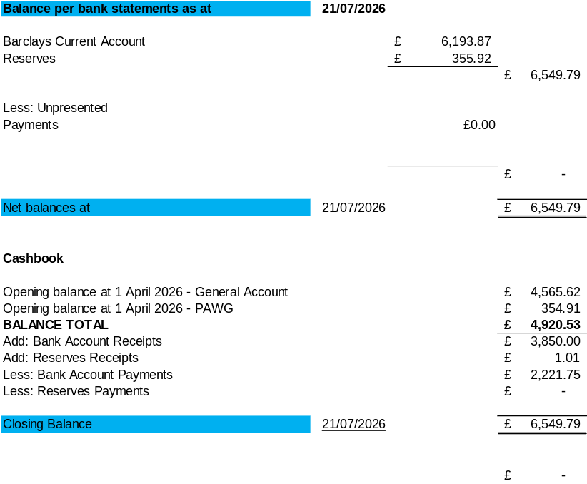

Councillor Goulding proposed for the Chair and the Responsible Finance Officer to sign the Bank Reconciliation dated 21st July 2026, seconded by Councillor Harrison.
26.70.02 To consider the Clerk’s request to increase mileage rates in line HMRC rates and approve back pay from April 2026.
Councillor Harwood proposed to increase the mileage rate and approve the Clerk’s mileage back pay of £5.04, seconded by Councillor Harrison.
26.70.03 To note any receipts and approve payments as detailed in July’s payment schedule.
FOR APPROVAL
 | DATE | EXPENDITURE | PAYMENT METHOD | TOTAL | VAT
Clerk | 27.07.26 | July Salary | BACS | £223.07 | £0.00
Clerk | 27.08.26 | August salary | BACS | £223.07 | £0.00
Clerk | 22.07.26 | July/August WFH and expenses | BACS | £70.90 | £0.00
Loddon Garden & DIY | 22.07.26 | Grass cutting payment | BACS | £550.00 | £91.67
Norfolk ALC | 22.07.26 | 26/27 subscription | BACS | £67.89 | £0.00
HMRC | 22.07.26 | PAYE up to 5th August 2026 | BACS | £55.60 | £0.00
HMRC | 27.08.26 | PAYE up to 5th September 2026 | BACS | £55.60 | £0.00
TO NOTE INCOME
Barclays | 08.06.26 | Interest | BACS | £1.01 | £0.00
Councillor Harwood proposed to approve July’s Payment Schedule, seconded by Councillor Goulding.
26.71 Staff:
26.71.01 To acknowledge and accept the Clerk’s resignation.
Acknowledged and accepted.
26.71.02 To confirm and approve job advert and application acceptance timeframe.
Councillor Harwood proposed to approve the job advert and application deadline of 12th August 2026, seconded by Councillor Goulding.
26.71.03 To confirm hours and rate of pay.
Councillor Harwood proposed to keep the hours of 17.33 per month and salary range of SCP13-SCP17, seconded by Councillor Goulding.
26.71.04 To approve the updated Job Description and Contract.
Councillor Harwood proposed to approve the Job Description and Contract subject to the following amendments to the contract:
Continuous Service to be discussed at interview.
Keep clause confirming 10 hours per month of paid overtime.
Add ‘Noticeboard keys’ to list of assets in Clerk’s possession.
Seconded by Councillor Goulding.
26.72 Planning: None at time of publication.
Noted.
26.73 Correspondence:
26.73.01 Notes from Bramerton Parish Council regarding the Highways meeting held on Tuesday 2nd July.
Councillor Harwood gave an overview of what was discussed at the meeting held with Harvey Woodyatt from Norfolk County Council Highways on Thursday 2nd July:
  - Road closure decision process - Road (and street) closure procedures are laid down in the ‘Safety at Street Works and Road Works’ Red Book (2013). This gives priority (in order) to pedestrian safety, roadworkers safety and finally road users.
  - The impact of road closures on local businesses - there is no requirement for the contractors to specify where the works are but to give sufficient notice for through traffic. Mr Woodyatt was asked if local businesses/councils might add their own temporary signs and said this might be acceptable if they were safely positioned but there was a risk they could be cleared away by contractors.
  - Lack of coordination between and advance notice regarding road closures – the national website https://one.network tracks current and future planned road closures. It is open to the public and if a user registers with the site, they can see future proposed closures and receive alerts for an area they specified.
  - Delays in roads being reopened following the completion of works - why road diversions often come into force before and end after works had been completed. It was confirmed that the signage is normally subcontracted to a different company than the works. Consequently, they would set up and remove them on the agreed dates regardless of the actual duration of the work. Norfolk County Council had been working with the police to ensure the commissioned contractor removed signs promptly once works were complete.
  - The suitability and safety of diversion routes - traffic is often forced onto unsuitable roads by diversions travelling at high speeds through small villages, with proposed diversions often taking drivers several miles in the wrong direction and unlikely to be adhered to. Instead using unsuitable minor roads without adequate passing places. It was asked why minor roads were not signposted ‘local access only’, made one way for the duration of the works or controlled by traffic lights for safety. Neither Highways or the police had the resources to set up or enforce such measures. Diversions were not enforceable and were just advisory for road users.
  - Agreeing appropriate bus routes through road closures – reports of near misses when bus services were diverted up unsuitable roads and cases of them getting trapped by the oncoming traffic. Others identified that vital public transport routes became unreliable during prolong road disruption. Mr Woodyatt confirmed that the bus operators and drivers decided on the route to take through road closures.
  - Business open as usual signs would be beneficial.
  - Traffic lights instead of road closures - Pedestrians must always have safe access to pass and a carriageway of at least 3m width was required for single file traffic. As a consequence, most rural roads would have to be closed to facilitate substantial works compliant with the Red Book.
  - The safety and placement of road signs - issue of temporary road signs obstructing views at road junctions. Reporting any concerns would be to go via the County Council Website
https://www.norfolk.gov.uk/highwaysproblem, attaching a photo of the back of the sign with a time stamp to assist with timely action being taken.
26.74 To receive updates from individual Council Members (for information only).
None.
26.75 To receive any items for inclusion on the next agenda (for information only).
Play Area update.
BNG report for play area for tree planting.
26.76 To confirm date and time of the next Meeting as Tuesday 15th September 2026.
Confirmed.

The meeting closed at 20:34pm

